Projeto Filtro IIR - Chebyshev II 1
Projeto Filtro FIR - Janela Fixa 7
% %% Dados
% % HP - (fa = 4000 Hz, f1 = 1000 Hz; f2 = 1300 Hz, Ap = 0.5 dB, As = 40 dB, GdB = 0 dB)
% % IIR - Chebyshev II, FIR - Janela Fixa
%

Projeto Filtro IIR - Chebyshev II
clear all;
close all;
clc;
Ap = 0.5; % Ganho na banda de passagem em dB
As = 40; % Atenuação no stopband em dB
fa = 4000; % Hz
f1 = 1000; % Hz
f2 = 1300; % Hz
GdB = 0; % dB
fs = f1;
fp = f2;
ws = 2*pi*fs;
wp = 2*pi*fp;
wa = fa * 2 * pi;
tetha_s = ws/(wa/2);
tetha_p = wp/(wa/2);
lambda_s = 2*tan(tetha_s * pi/2);
lambda_p = 2*tan(tetha_p * pi/2);
Os = lambda_p/lambda_s;
Op = 1;
% Filtro Chebyshev 2
Rp = Ap; Rs = As;
[n,Wn] = cheb2ord(Op,Os,Rp,Rs,'s');
[b,a] = cheby2(n,Rs,Wn,'s');
% Plot protótipo filtro PB
figure(1)
[h1,w1] = freqs(b,a,logspace(-2,1,1000));
semilogx(w1,20*log10(abs(h1)));grid on; ylim([-60 5]);
title('H(p)');xlabel('rad/s');ylabel('dB');
hold on
grid on
plot([10^-2,Os,Os,10^1],[0,0,-As,-As], '--r')
plot([10^-2,1,1],[-Ap,-Ap,-80], '--r')
% Transformação de frequência Lowpass para Highpass
ap = a; bp = b;
syms p;
Np(p) = poly2sym(bp, p);
Dp(p) = poly2sym(ap, p);
Hp(p) = Np(p) / Dp(p);
pretty(vpa(collect(Hp(p)), 5))
% transformação de frequência
syms s;
Hs(s) = collect(subs(Hp(p),lambda_p/s));%transformação lowpass -> bandstop
[N, D] = numden(Hs(s));
pretty(vpa(Hs(s), 5))
% Normalizando de acordo com p^n
bs = sym2poly(N);
as = sym2poly(D);
an = as(1);
bsn = bs/an;
asn = as/an;
Hsn(s) = poly2sym(bsn, s)/poly2sym(asn, s);
pretty(vpa(Hsn(s), 5))
% Plot filtro HP
figure(2)
[h, w] = freqs(bsn,asn, linspace(0, 100, 10000));
plot(w/pi, 20*log10(abs(h))); grid on;hold on;ylim([-80 5]);xlim([0 2])
title('H(s)');xlabel('rad/s');ylabel('dB');
% Fazer a mascara em cima do LAMBDA
plot([0,lambda_s/pi,lambda_s/pi,2],[-As,-As,0,0], '--r')
plot([lambda_p/pi,lambda_p/pi,2],[-80,-Ap,-Ap], '--r')
syms z;
aux = 2*((z-1)/(z+1));
Hz(z) = collect(subs(Hs(s), aux));
pretty(vpa(Hz(z),3))
[Nz,Dz] = numden(Hz(z));
bz = sym2poly(Nz);
az = sym2poly(Dz);
an = az(1);
bzn = bz/an;
azn = az/an;
Hzn(z) = poly2sym(bzn,z) / poly2sym(azn,z);
pretty(vpa(Hzn(z),5))
figure(3)
subplot(211)
[hz, wz] = freqz(bzn,azn, linspace(0, pi, 1000));
plot(wz/pi*fa/2, 20*log10(abs(hz))); grid on;hold on;ylim([-60 5])
title_txt = ['H(z) - BP - Filtro IIR - Chebyshev II - N = ' num2str(n)];
title(title_txt);xlabel('Hz');ylabel('dB');
% Máscara do filtro projetado
plot([0,fs,fs,2000],[-As,-As,0,0], '--r')
plot([fp,fp,2000],[-60,-Ap,-Ap], '--r')
hold off;
subplot(212)
plot(wz/pi*fa/2, 20*log10(abs(hz))); grid on;hold on;ylim([-5 2]);xlim([1250 2000]);
title_txt = ['H(z) - BP - Filtro IIR - Chebyshev II - N = ' num2str(n)];
title(title_txt);xlabel('Hz');ylabel('dB');
% Máscara do filtro projetado
plot([0,fs,fs,2000],[-As,-As,0,0], '--r')
plot([fp,fp,2000],[-80,-Ap,-Ap], '--r')
hold off;
figure(4)
subplot(121)
zplane(bzn, azn);title('Diagrama de pólos e zeros');xlabel('Parte real');ylabel('Parte imaginária');axis([-2 2 -3 3]);
subplot(122)
grpdelay(bzn, azn);title('Atraso de grupo');
xlabel('Frequência normalizada [x\pi rad/amostra]');
ylabel('Atraso de grupo [amostra]');
%%%%%%%%%%%%%%%%%%%%%%%%%%%%%%%%%%%%%%%%%%%%%%%%%%%%%%%%%%%%%%%%%%
figure(5)
subplot(211)
% valores retirados do Filter Designer
Den = [1 0.877075195312500 1.203308105468750 0.426635742187500 0.249557495117188 0.020889282226563 0.006622314453125];
Num = [0.055919647216797 -0.136375427246094 0.237262725830078 -0.275764465332031 0.237262725830078 -0.136375427246094 0.055919647216797];
N = Num;
D = Den;
plot(wz/pi*fa/2, 20*log10(abs(hz)));
grid on;hold on;
[hzq, wzq] = freqz(N, D, linspace(0, pi, 10000));
plot(wzq/pi*fa/2, 20*log10(abs(hzq)));ylim([-60 5]);
title_txt = ['H(z) - BP - Filtro IIR - Chebyshev II - N = ' num2str(n)];
title(title_txt);xlabel('Hz');ylabel('dB');
% Máscara do filtro projetado
plot([0,fs,fs,2000],[-As,-As,0,0], '--r')
plot([fp,fp,2000],[-60,-Ap,-Ap], '--r')
legend('Filtro projetado','Filtro quantizado');
hold off;
subplot(212)
plot(wz/pi*fa/2, 20*log10(abs(hz)));ylim([-5 2]);xlim([1250 2000]);
title_txt = ['H(z) - BP - Filtro IIR - Chebyshev II - N = ' num2str(n)];
title(title_txt);xlabel('Hz');ylabel('dB');
grid on;hold on;
plot(wzq/pi*fa/2, 20*log10(abs(hzq)));
% Máscara do filtro projetado
plot([0,fs,fs,2000],[-As,-As,0,0], '--r')
plot([fp,fp,2000],[-60,-Ap,-Ap], '--r')
legend('Filtro projetado','Filtro quantizado');
hold off;
figure(6)
subplot(121)
zplane(bzn, azn);title('Diagrama de pólos e zeros projetado');xlabel('Parte real');ylabel('Parte imaginária');axis([-2 2 -3 3]);
subplot(122)
zplane(N, D);title('Diagrama de pólos e zeros quantizado');xlabel('Parte real');ylabel('Parte imaginária');axis([-2 2 -3 3]);
hold off;
%%%%%%%%%%%%%%%%%%%%%%%%%%%%%%%%%%%%%%%%%%%%%%%%%%%%%%%%%%%%%%%%%
32 6 16 5 33 4 18 3
(1.6226 10 p + 5.6531 10 p + 7.6113 10 p + 2.3136 10 p
34 2 18 34 34 6
+ 5.2893 10 p + 4.4475 10 p + 9.1893 10 )/(1.6226 10 p
34 5 35 4 35 3 35 2
+ 7.9017 10 p + 1.9248 10 p + 2.9911 10 p + 3.1734 10 p
35 34
+ 2.2046 10 p + 9.1893 10 )
95 5 112 4 96 3 112 2
(#1 + 8.4038 10 s + 3.2619 10 s + 4.6565 10 s + 4.9997 10 s
96 112 112 5 113 4
+ 1.212 10 s + 1.1353 10 )/(#1 + 4.1657 10 s + 1.957 10 s
113 3 114 2 114 114
+ 6.0203 10 s + 1.2643 10 s + 1.694 10 s + 1.1353 10 )
where
111 6
#1 == 5.3202 10 s
6 -16 5 4 -16 3 2
(s + 1.5796 10 s + 6.1311 s + 8.7525 10 s + 9.3976 s
-16 6 5 4 3
+ 2.278 10 s + 2.134)/(s + 7.8299 s + 36.785 s + 113.16 s
2
+ 237.65 s + 318.41 s + 213.4)
113 6 114 5 114 4 114 3
(5.37 10 z - 1.31 10 z + 2.28 10 z - 2.65 10 z
114 2 114 113 114 6
+ 2.28 10 z - 1.31 10 z + 5.37 10 )/(9.6 10 z
114 5 115 4 114 3 114 2
+ 8.42 10 z + 1.16 10 z + 4.1 10 z + 2.4 10 z
113 112
+ 2.01 10 z + 6.36 10 )
6 5 4 3 2
(0.055919 z - 0.13638 z + 0.23726 z - 0.27577 z + 0.23726 z - 0.13638 z
6 5 4 3 2
+ 0.055919)/(z + 0.87708 z + 1.2033 z + 0.42663 z + 0.24955 z
+ 0.020886 z + 0.0066225)
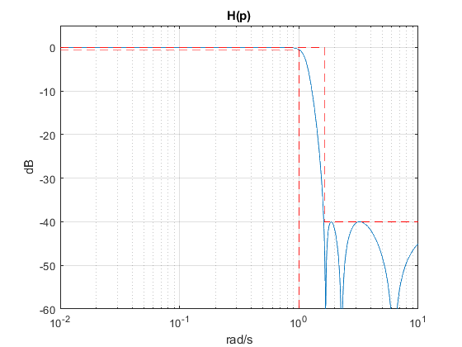
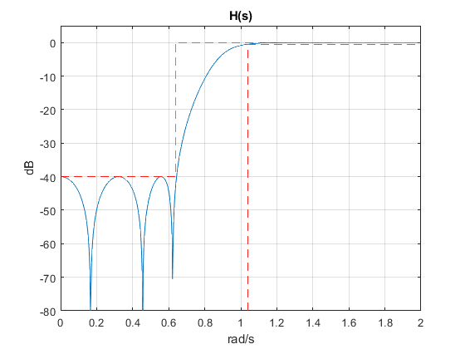
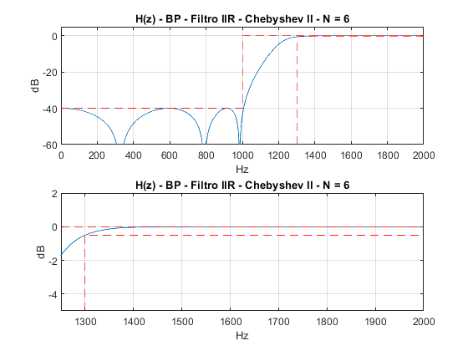
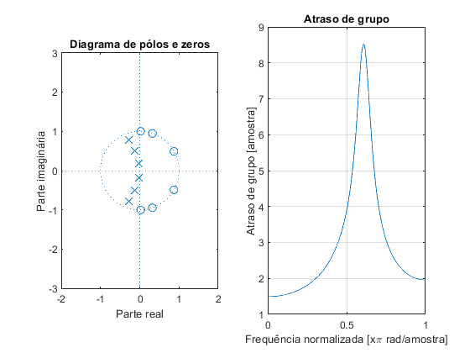
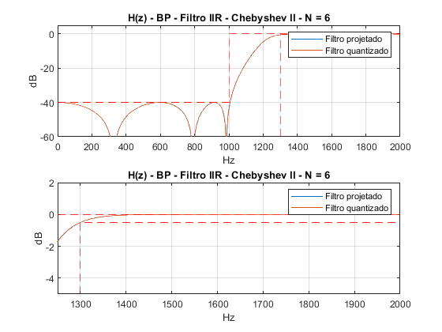
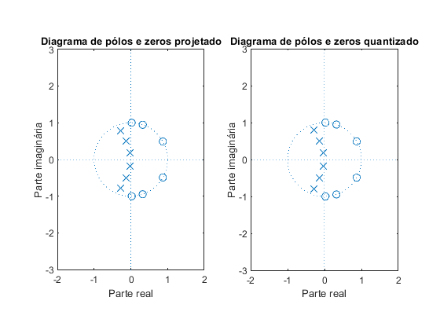

Projeto Filtro FIR - Janela Fixa
clear all;
clc;
Ap = 0.5; % Ganho na banda de passagem em dB
As = 40; % Atenuação no stopband em dB
fa = 4000; % Hz
f1 = 1000; % Hz
f2 = 1300; % Hz
GdB = 0; % dB
g0 = GdB;
f = [1000 1300]; % frequências em Hz
% substituindo de Hz para ômega
w = f/fa*(2*pi); %w = 2*pi*f
ws = w(2);
wp = w(1);
%projeto original
Dw = ws - wp;
%M = ceil(3.32*pi/Dw); % ordem (3.32 tabela Hamming)
M = ceil(3.11*pi/Dw); % ordem (3.11 tabela Hann)
%Ajuste de ordem
M= M-4;
%Ajuste do ganho
%levar o pico para abaixo de 0
ganho = 0.05501; %ganho dB mediddo no plot do filtro
g0 = ganho;
% primeiro ajuste de M (N/2)
wp1 = 0.4998*pi; ws1 = ws; % valores medidos no gráfico
Dw1 = ws1 - wp1;
M2 = ceil(M*Dw1/Dw);
M = M2;
wc = sqrt(wp*ws); % frequência de corte, média das frequências
wc = wc + 0.0440; % ajuste da frequencia de corte
k = 1:M;
% Highpass
bi = -sin(k*wc)./(k*pi);
b0 = 1 - ( wc/pi);
b = [flip(bi) b0 bi];
m = -M : M;
%dw = 0.04; % filtro hamming
dw = 0.00; % filtro hann
wk = (0.5+dw)+(0.5-dw)*cos(2*pi*m/(2*M+1)); %serve para filtro hamming ou hann
b = b.*wk*10^(-g0/20);
% Acertar a janela no plot
ws = w(2);
wp = w(1);
figure(7)
subplot(211)
[h, w] = freqz(b,1,linspace(0,pi,10000));
plot(w/pi*fa/2,20*log10(abs(h))); grid on;ylim([-80 5]);
title_txt = ['H(z) - BP - FIR - Janela Fixa - N = ' num2str(M*2)];
hold on;
title(title_txt);xlabel('Hz');ylabel('dB');
plot([0 f1 f1 2000],[-As -As 0 0], '--red')
plot([f2,f2,2000],[-80 -Ap,-Ap], '--red')
hold off;
subplot(212)
plot(w/pi*fa/2,20*log10(abs(h))); grid on;ylim([-5 2]);xlim([1250 2000]);
hold on;
title_txt = ['H(z) - BP - FIR - Janela Fixa - N = ' num2str(M*2)];
title(title_txt);xlabel('Hz');ylabel('dB');
plot([0 f1 f1 2000],[-As -As 0 0], '--red')
plot([f2,f2,2000],[-80 -Ap,-Ap], '--red')
hold off;
figure(8)
subplot(121)
zplane(b, 1);title('Diagrama de pólos e zeros');xlabel('Parte real');ylabel('Parte imaginária');axis([-2 2 -3 3]);
subplot(122)
grpdelay(b, 1);title('Atraso de grupo');
xlabel('Frequência normalizada [x\pi rad/amostra]');
ylabel('Atraso de grupo [amostra]');
%%%%%%%%%%%%%%%%%%%%%%%%%%%%%%%%%%%%%%%%%%%%%%%%%%%%%%%%%%%%%%%%%%
figure(9)
subplot(211)
% valores retirados do Filter Designer
Num = [0 0 0.0009765625 -0.0009765625 -0.001953125 0.0048828125 0 -0.009765625 ...
0.0068359375 0.013671875 -0.0205078125 -0.0087890625 0.0400390625 -0.0126953125 ...
-0.0615234375 0.0693359375 0.0771484375 -0.302734375 0.4130859375 -0.302734375 ...
0.0771484375 0.0693359375 -0.0615234375 -0.0126953125 0.0400390625 -0.0087890625 ...
-0.0205078125 0.013671875 0.0068359375 -0.009765625 0 0.0048828125 -0.001953125 ...
-0.0009765625 0.0009765625 0 0];
N = Num;
plot(w/pi*fa/2,20*log10(abs(h))); grid on;ylim([-90 5]);hold on;
[hq, wq] = freqz(N, 1, linspace(0, pi, 10000));
plot(wq/pi*fa/2, 20*log10(abs(hq)));
title_txt = ['H(z) - BP - FIR - Janela Fixa - N = ' num2str(M*2)];
title(title_txt);xlabel('Hz');ylabel('dB');
% Máscara
plot([0 f1 f1 2000],[-As -As 0 0], '--red')
plot([f2,f2,2000],[-80 -Ap,-Ap], '--red')
legend('Filtro projetado','Filtro quantizado');
hold off;
subplot(212)
plot(w/pi*fa/2, 20*log10(abs(h)));ylim([-5 2]);xlim([1250 2000]);
title_txt = ['H(z) - BP - FIR - Janela Fixa - N = ' num2str(M*2)];
title(title_txt);xlabel('Hz');ylabel('dB');
grid on;hold on;
plot(wq/pi*fa/2, 20*log10(abs(hq)));
% Máscara
plot([0 f1 f1 2000],[-As -As 0 0], '--red')
plot([f2,f2,2000],[-80 -Ap,-Ap], '--red')
legend('Filtro projetado','Filtro quantizado');
hold off;
figure(10)
subplot(121)
zplane(b, 1);title('Diagrama de pólos e zeros projetado');xlabel('Parte real');ylabel('Parte imaginária');axis([-2 2 -3 3]);
subplot(122)
zplane(N, 1);title('Diagrama de pólos e zeros quantizado');xlabel('Parte real');ylabel('Parte imaginária');axis([-2 2 -3 3]);
hold off;
%%%%%%%%%%%%%%%%%%%%%%%%%%%%%%%%%%%%%%%%%%%%%%%%%%%%%%%%%%%%%%%%%
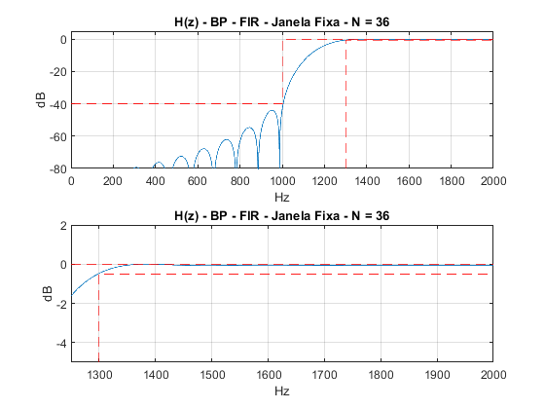
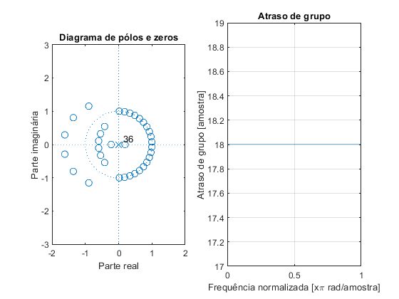
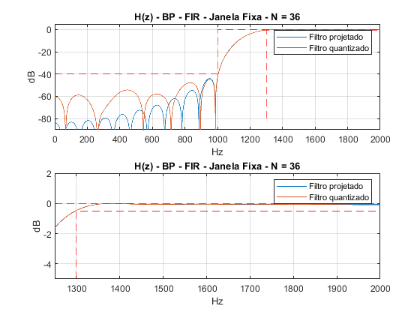
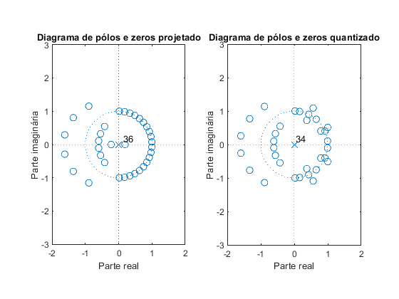
Published with MATLAB® R2018a

